我的任务是主题分类，但是原始数据没有主题标签，所以我的分析思路是：
1先对数据做预处理；
2基于评论用LDA主题模型寻找最优的分类数量，并根据主题词的分布归纳得到4个主题 (0: "Design & Portability", 1: "Performance & Quality", 2: "Appearance & Satisfaction", 3: "Logistics & Service")，根据每句评论主题词出现的频率给所有数据打上主题标签（camera_labeled.csv）。通过统计不同主题在品牌中的分布以及各品牌的词云图，可以得到消费者更关注哪些性能以及不同品牌的卖点；
3 当我们拿到一个全新的评论时，希望可以判断他的主题，便于我们给出分析和商业建议，因此运用机器学习，集成学习和TextCNN做了多分类，并对比各个模型的Accuracy和F1
具体的流程细节，图表和分析结论如下。

Discussion (Each group present the following items you are planned in 8 mins):
Q1 What data collection, cleansing, and data pre-processing you have done?
data pre-processing: data cleaning, Chinese word segmentation, and stop word filtering
Q2 What data analysis and/or expected business insights you have done?
下面第2部分内容

Topic Classification - Camera Brand JD

1 Overview of Research Methods
After completing preprocessing such as data cleaning, Chinese word segmentation, and stop word filtering on the JD camera comment data, this research carried out word cloud visualization analysis, LDA topic model modeling (completing optimal topic number optimization and topic annotation), machine learning model classification (Logistic Regression, Naive Bayes, SVM, etc.), ensemble learning method optimization (Voting Ensemble, Stacking Ensemble) and deep learning TextCNN model modeling in turn. Finally, the classification effects of all models were quantitatively compared to screen out the optimal topic classification model. The whole research process ensures the consistency of data processing and controllable randomness of model training to guarantee the reliability of results.

2 Core Analysis Conclusions

2.1 LDA Topic Model: Mining Four Core User Discussion Topics
Through the optimization of the LDA topic model, the optimal number of topics for the comment data is determined to be 4. The topic naming and interpretation are completed based on the characteristics of topic keywords. The four topics cover the full-dimensional feedback of users on camera products and services, and the core characteristics and commercial value of each topic are as follows:
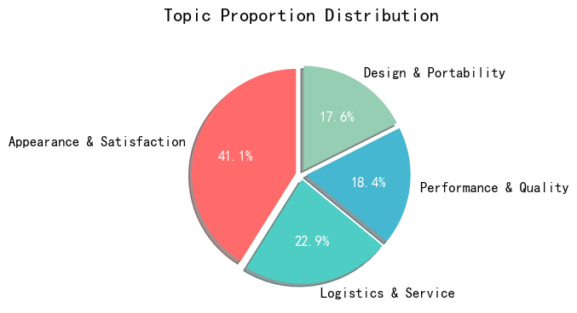
- Design & Portability: The core keywords are effect, imaging, appearance, portability, compact, etc. It is the core discussion point of users on the physical attributes and basic use experience of camera products, reflecting the brand's competitiveness in hardware aspects such as product appearance design and portability optimization, and is an important consideration for entry-level users when purchasing cameras.
- Performance & Quality: The core keywords are video, focusing, image quality, shooting, operation, etc., and the brand word "Sony" appears, indicating that Sony has the highest mention rate in users' performance discussions. This topic focuses on the core functional performance of cameras, is the focus of professional and advanced users, and is also a key dimension for brands to create product differentiation.
- Appearance & Satisfaction: Accounting for 41.08%, it is the topic with the highest proportion among the four major topics. The core keywords are like, satisfied, appearance, recommend, etc., reflecting users' comprehensive evaluation and emotional tendency towards cameras. The high proportion indicates that users' subjective satisfaction is the core content of comments and a direct reflection of brand reputation building.
- Logistics & Service: The core keywords are logistics, customer service, JD.com, genuine product, received, etc., and the brand word "Nikon" appears at the same time, indicating that Nikon's logistics and after-sales service are the focus of user discussions. This topic reflects the user experience of e-commerce platform services and brand after-sales supporting facilities, and is an important non-product factor affecting users' purchase decisions and repurchase intentions.

2.2 Brand Topic Distribution: Significant Differentiation in the Focus of User Discussions for Each Brand
The comment distribution of each brand under the four major topics shows significant differences, which directly reflects the differentiated characteristics of the cognitive positioning and core competitiveness of different brands in the user's mind:
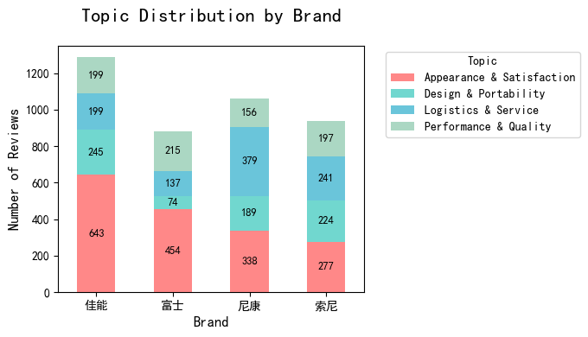
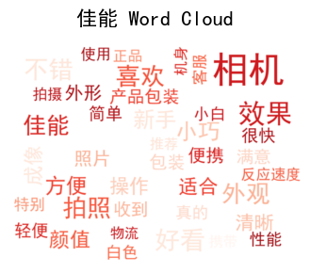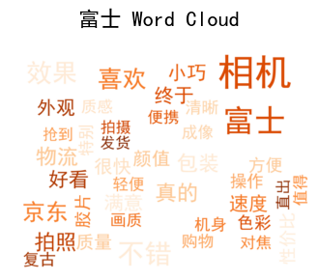
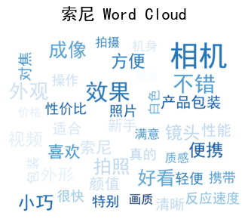
- Canon: Ranked first among the four major brands with 643 comments under the topic of Appearance & Satisfaction, and the comment distribution of the four major topics is relatively balanced with the comment volume of each dimension at a high level. It reflects that Canon's products have excellent comprehensive experience performance, high overall user satisfaction, no obvious shortcomings in brand reputation, and are a benchmark brand with balanced performance in all dimensions.
- Fujifilm: Design & Portability is the core discussion topic. Although the 74 comments in this dimension are the highest of the brand itself, its proportion in this dimension is still the core focus direction compared with other brands. It confirms that Fujifilm's product design, portability and appearance are its core advantages most recognized by users, and also the most recognizable marketing selling point of the brand.
- Nikon: The number of comments under the topic of Logistics & Service reached 379, far exceeding other brands and its own other topics, becoming the primary discussion point of Nikon users. It shows that Nikon has outstanding user experience performance in e-commerce logistics distribution, after-sales service guarantee and other links, which is the core differentiated competitiveness formed by the brand at the non-product level.
- Sony: The number of comments under the topic of Performance & Quality was 197, the highest of the brand itself, and it is the core attention dimension of Sony users. It highlights that the hard power such as core performance, image quality performance and shooting experience of Sony cameras is the key to attracting users, and also becomes the most distinctive brand label of Sony in the market.

2.3 Model Performance Comparison
To underpin the digital marketing initiatives of brands, this study develops a topic classification model and generalizes its classification capability to unseen data. This enables high-precision automated classification of camera review topics, supporting brands in building a real-time review monitoring system to quickly capture shifts in consumer discussion hotspots and demand trends.
The classification effects (Accuracy, Weighted F1-score) of single machine learning models, ensemble learning models and deep learning TextCNN models are quantitatively compared, and the following core conclusions are drawn:
Model | Accuracy | Weighted F1
Logistic Regression | 0.8285 | 0.8281
Naive Bayes | 0.8237 | 0.8227
SVM | 0.8345 | 0.8353
TextCNN | 0.7950 | 0.7939
Soft Voting (LR+SVM) | 0.8417 | 0.8424
Hard Voting (3 models) | 0.8381 | 0.8377
Soft Voting (3 models) | 0.8429 | 0.8433
Weighted Voting (3 models) | 0.8417 | 0.8421
Stacking (Meta: NB) | 0.8381 | 0.8388
Hard Voting (LR+SVM) | 0.8357 | 0.8345
Stacking (LR+SVM, Meta: LR) | 0.8441 | 0.8447
Stacking (Meta: SVM) | 0.8429 | 0.8435
Stacking (Meta: LR) | 0.8417 | 0.8424

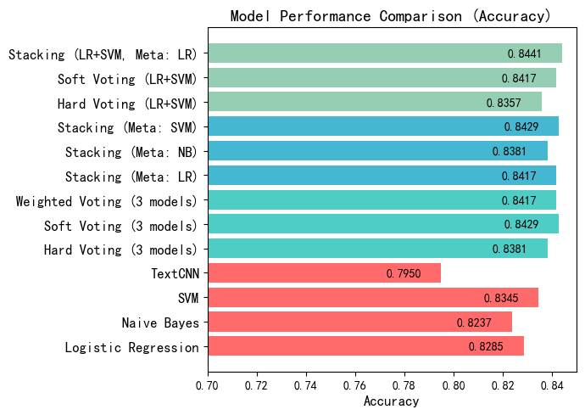

- Ensemble learning models perform significantly better than single models: The accuracy and F1 values of most ensemble learning models are higher than those of single machine learning models such as Logistic Regression, Naive Bayes and SVM, and also higher than the deep learning TextCNN model (accuracy 0.7950). It indicates that the way of multi-model fusion can effectively make up for the classification shortcomings of single models and improve the accuracy and stability of topic classification.
- Stacking (LR+SVM, Meta: LR) is the optimal model: This model has become the optimal solution among all models with 84.41% accuracy and 84.47% weighted F1 value, and is the best model for topic classification of camera comment text. This model combines the advantages of Logistic Regression and SVM, completes model fusion through a secondary Logistic Regression meta-learner, and has the strongest adaptability to feature capture of comment text and topic classification.
- SVM performs the best among single models: Among single machine learning models, the SVM model has the highest accuracy (83.45%) and F1 value (83.85%), which is better than Logistic Regression and Naive Bayes, indicating that the nonlinear fitting ability of the kernel function method to text features is more suitable for the text data features of camera comments.
- TextCNN model performance is relatively weak: The classification effect of the deep learning TextCNN model is the worst among all models. It is speculated that the reason is that camera comment texts are mostly short sentences with relatively simple feature dimensions. The complex feature extraction ability of the deep learning model is difficult to exert its advantages, and there is a risk of overfitting instead.

